

The Peoples Republic of Bangladesh
Ministry of Health &Family Welfare (Health Service Division)
Health Economic Unit (HEU). Shasta Surakkha Kormochuci (SSK)
Topkhana Road, Dhaka-1000

Visit Report: Ramgoti Upazila Health Complex, Lakshmipur
Date of Visit: 01/08/22; Time: 9:30 AM.
Visitor: Dr. Md. Mostafizur Rahman, Deputy Secretary (HEU) of MoHFW &,
Dr. Md. Emdadul Haque, National Consultant (HEU) of MoHFW

1. We met with the UH&FPO of the hospital Dr. Kamonashish Mojumder, RMO and other Medical Officers. One of them is Anaesthesiologist and one having FCPS degree on Medicine. One medical officer Dr. Fatema Akter having (FCPS-Part-1) on Gynae. She has got training on Gynae for 18 months from Mymensingh medical college. Dental surgeon is performing effectively in the hospital. We discussed with them about the overall situation of health complex. All the physicians were present during the discussion session.
2. The building was situated close to the bank of the Meghna river. There are 8 unions under the Upazila Health Complex.
3. One of the unions which is an island named Chor Abdullah. This island having population of 15000. There is no sub-centre, SWC or community clinic at that island. One HA & FWA is working there. The distance of the island is nearly 15-20 km from main land. The only transport they had is Engine Boat and nearly 2.5 hours is needed to travel to main land from there. No medical assistant works there.
3. We visited outdoor of Upazila Health Complex. The outdoor was over crowded. The infra-structure of this hospital is 20 bedded but functioning as 31 bedded hospital. There are outdoor services, dental outdoor, X-ray, pathology and pharmacy department and 24/7 blood transfusion system. There is no medical technologist (Lab), but a MT (TB) working as MT (Lab). The information display system is very weak, no health education system is there.

4. Cleanliness of the indoor is not satisfactory. No separate operation theatre was there. Labor room is using as operation theatre.
5. There is beautiful garden in front of the hospital.
6. Cycle stand is away from the main gate.
7. Waste management system is very weak. Backyards of the hospital is unclean.
8. Ante-natal services are weak.
9. The position in health service system (HSS score) was 219 in May-22 and 212 in June-22 among all the UHC of the country.
10. In June-22, the bed occupancy rate in was 100.25%, OPD patient was 7,263. total NVD was 98.

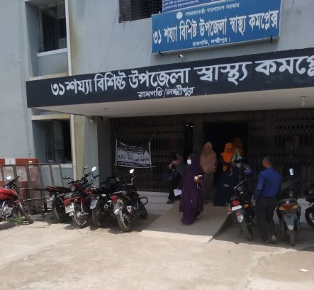
Fig-1: Front side of Ramgoti UHC, Lakshmipur

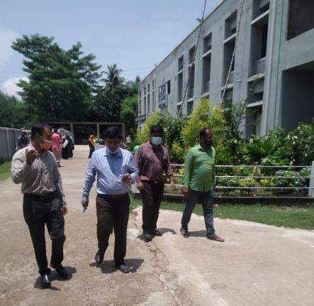
Fig-2: Beautiful garden in front of UHC (Good practice)

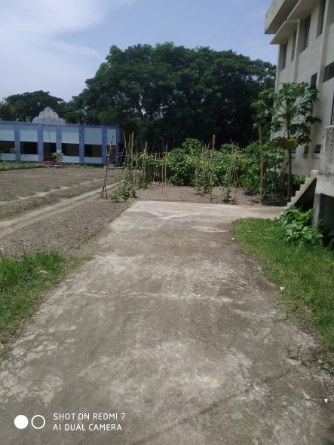
Fig-3: Residential area of the hospital is being used as vegetable garden
(Good Practice)
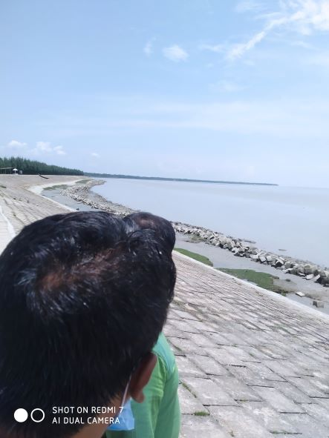
Fig-4: Ramgoti UHC situated in the bank of Meghna river. Part of the
baribadh with in the area of the UHC.

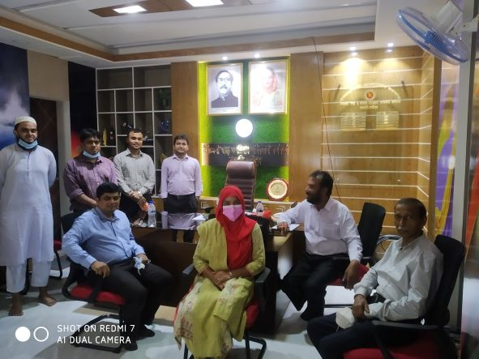
Fig-5: The room of UH&FPO is well decorated (Good practice)

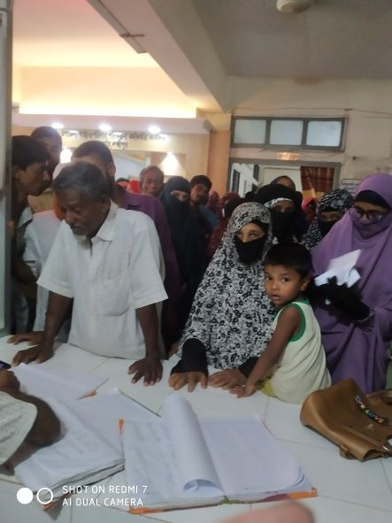
Fig-6: Overcrowded and no queue in ticket counter

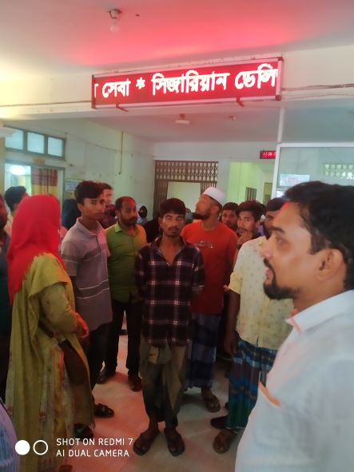
Fig-7: Digital display of health message (Good practice)

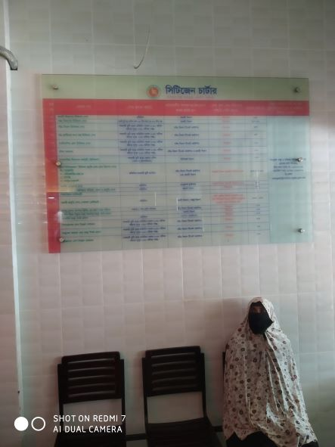
Fig-8: Beautiful display of Citizen charter (Good practice)

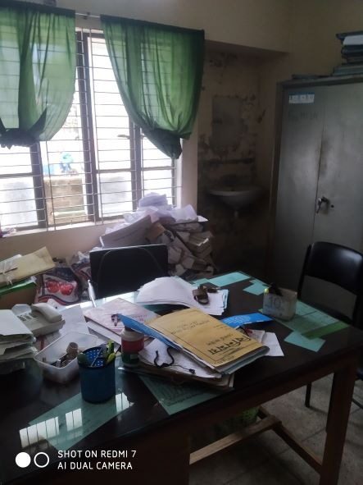
Fig-9: Disorganized office file management

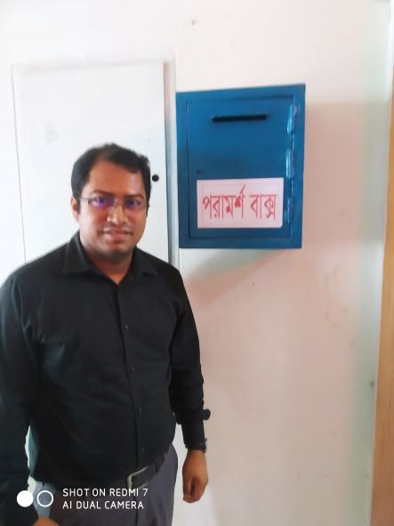
Fig-10: Suggestion box (Good practice)

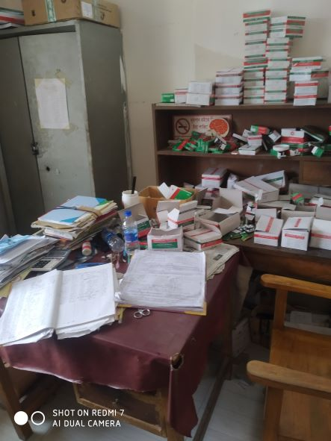
Fig-11: Disorganized Pharmacy

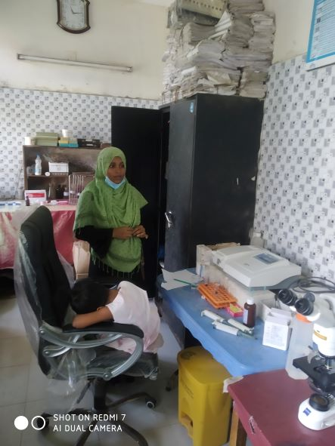
Fig-12: Disorganized Pathological Lab

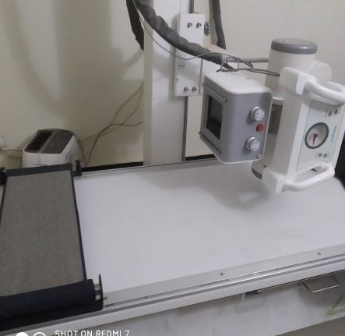
Fig-13: Functioning X-ray machine

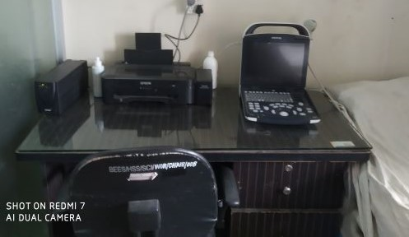
Fig-14: Functioning USG machine
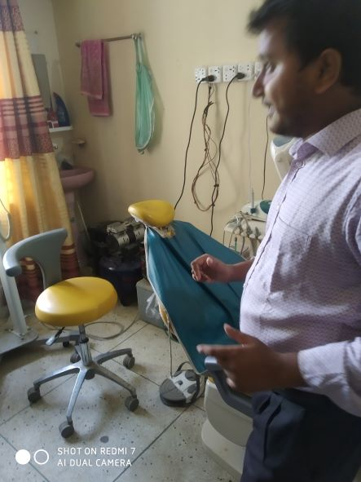
Fig-15: Functioning Dental unit with dental X-ray facility

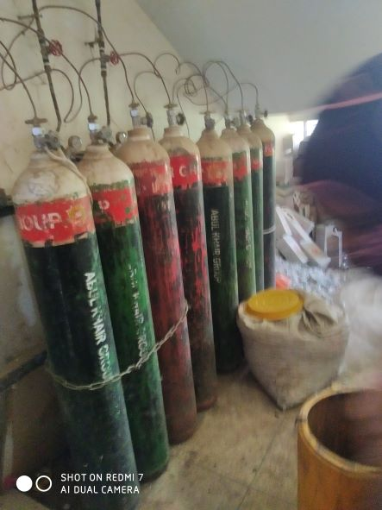
Fig-16: Central O₂ supply system with donated by Abul Khayer Group

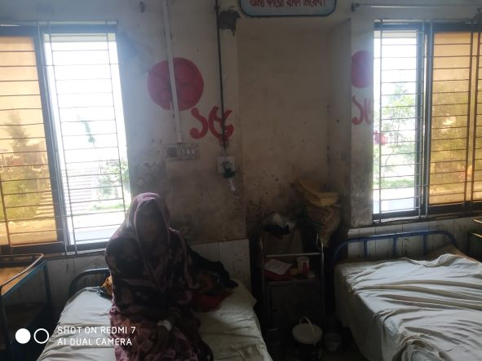
Fig-17: Unclean female indoor

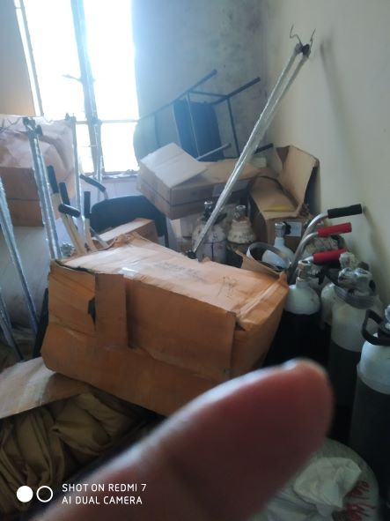
Fig-18: OT room is being used as store

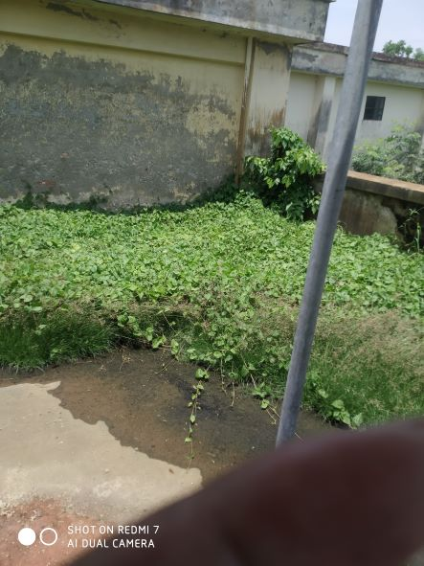
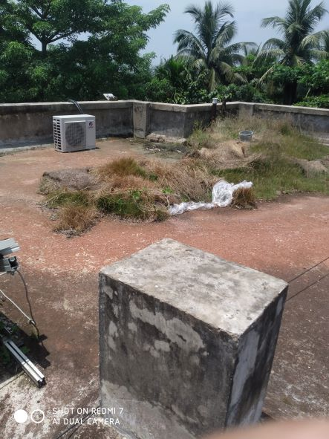
Fig-19,20: Rooftop of the building is mismanaged and filled with shrubs

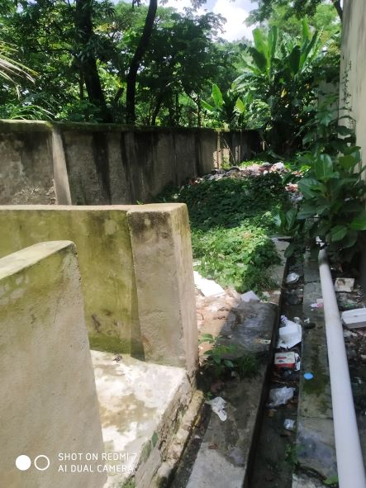
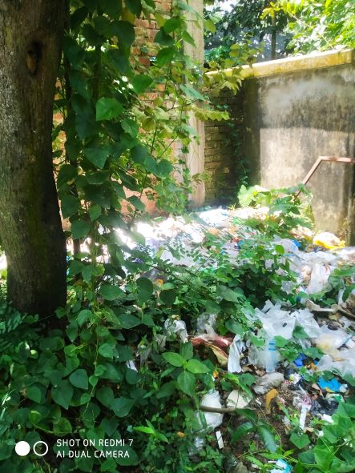
Fig-21,22: West side of the hospital is filled with hospital waste materials

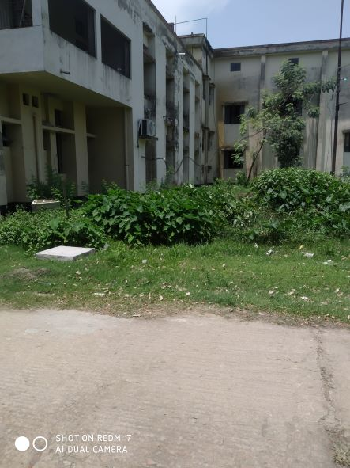
Fig-23: Backside of the health complex building

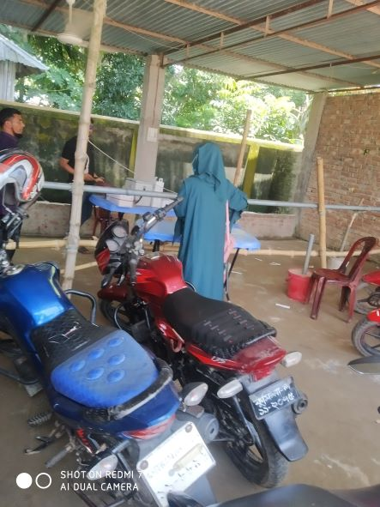
Fig-24: Cycle stand is far from the main gate

Health Profile of Ramgoti UHC, Ramgoti, Laxmipur
Total population: 2,30,000
Union: 7 Sub-centre: 2 FWC: 5 Community Clinic: 20
Human Resources: 31 Bedded Hospital:
Sl. | Designation | No. of Post | Present | Vacant
1. | UH&FPO | 1 | 1 | 0
2. | Junior Consultant: Medicine, Surgery, Gynae, Anestheology & Rheumatology. | 5 | 1  (Anesthesiology) | 4
3. | Medical Officer | 2 | 1 | 1
4. | Medical Officer (OSD) | 8 | 5  1 deputation,  2 work in Sub-centre | 0
5. | Nurses | 26 | 9  1 deputed in Dist. Hospital | 15
6. | Mid wives | 6 | 1  (2 deputed from Dist. Hospital) | 3
7. | Medical Technologist (Lab) | 3 | 1  (MT-TB) | 2
8. | MT EPI | 1 | 1 | 0
9. | Dental Technologist | 1 | Deputation in Dhaka Dental College | 0
10. | MT (Radiology) | 1 | 0 | 1
11. | SACMO | 9 | 8 | 1
12. | Health Inspector (HI) | 2 | 0 | 2
13. | Assist. Health Inspector | 9 | 6 | 3
14. | Health Assistant | 43 | 22 | 21
15. | CHCP | 20 | 18 | 2
16 | Head Assistant | 1 | 0 | 1
18. | Accountant | 1 | 1(In charge of Head. Asst &statistician) | 0
19. | MLSS | 4 | 0 | 4
20. | Cleaner | 5 | 2 | 3
21. | FWA | 36 | 26 | 10
 | Outsourcing: Cleaner, Cook, Guard, Ward boy, Aya. | 5(1+1+1+1+1) | 5 (Joined from 10/5/22) | 0

Human Resources: 20 Bedded Hospital
Sl. | Designation | No. of Post | Present | Vacant
1. | RMO | 1 | 1(Deputation at Chittagong Medical College) | 0
2. | Consultant | 4 | 0 | 4
3. | Medical Officer | 1 | 0 | 1
4. | Lab Attendant | 1 | 1(Deputation in Sadar Hospital)
5. | MT Lab | 1 | 0 | 1
6. | MLSS | 2 | 0 | 2
7. | Pharmacist | 1 | 0 | 1
8. | Office Assistant | 1 | 0 | 1
9. | Head Assistant cum Accountant | 1 | 0 | 1
10. | Cleaner | 1 | 0 | 1
11. | Word Boy | 2 | 2 (1 deputation in Dist. Hospital) | 1
 | Night Guard | 1 | 0 | 1
 | Cook | 1 | 0 | 1
 | Aya | 1 | 0 | 1

Status of Building Blocks of C-J Model in the Ramgoti UHC:
Sl | Criteria of C-J Model | Best | Good | Weak
 | Cycle stand close to the main gate |  |  | +
 | Health Education |  |  | +
 | Cleanliness & beautification |  | +
 | Separation of patients in out door & indoor |  |  | +
 | Blood doner list with 24/7 B.T facility |  | +
 | Birth- death recording |  |  | +
 | Reception Desk |  |  | +
 | Developed Emergency Dept. |  |  | +
 | 5S –KAIZEN implementation. |  |  | +
 | Community Participation. |  | +
 | Hospital activities Display |  |  | +
 | Corner based service. |  | +
 | Cash counter for receiving Govt money. |  |  | +
 | Devolped maternal health/labour word. |  |  | +
 | Devolped paediatric health |  |  | +
 | Position in HSS score |  |  | +
 | Power point Presentation &Video on UHC |  | +
 | Knowledge about 7th Five Year plan & SDG. |  |  | +
 | Zero-Tollarance on corruption |  | +

Recommendations:
1. The RMO is deputed at Chittagong Medical College. One medical officer is in charge of RMO. Since the RMO position is crucial, it should be immediately filled by another RMO.
2. For office management, the post of Head Assistant and Statistician is very important. Both the post is vacant. It should be filled immediately.
3. Cleanliness and beautification is not upto the mark. The Powroshova must take part in waste management.
4. Accomodation is the main problem, and need immediate infra-structure development (either by vertical extension or by 50 bedded infra-stucture).
5. There is no OT in the health complex. Labor room is also using as OT.
6. Condemetion Board should be done to remove the unwanted items.
7. Fourth class emplyee support is necessary (Guard, cleaner, Aya, Ward boy).
8. Minimum two (2) Medical Technologist (Lab) is necessary for pathology & Blood transfusion.
9. Replication of C-J model will help in development of the quality of care.
10. Unification of human resource of 20 bedded hospital and 31 bedded hospital is necessary.
11. All the post of consultants should be fulfilled specially Gynae consultant.
12. Radiogical service is going on but should be digitalized.
13. For Char Abdullah, need special attention, “Water Ambulance Service or using of Helicopter” for life saving purpose.
14. Suggestion box should be replaced to Complaint and suggestion box.
15. Protective shield for dental surgeon should be given as he performing dental X-rays.
16. The post of radiographer is vacant, but they are managing it with local fund.

Visit Report: Kamalnagar Upazila Health Complex, Lakshmipur
Date of Visit: 01/08/22; Time: 12:30 PM.
Visitor: Dr. Md. Mostafizur Rahman, Deputy Secretary (HEU) of MoHFW &,
Dr. Md. Emdadul Haque, National Consultant (HEU) of MoHFW

1. We met with the UH&FPO Dr. Abu Taher, RMO and other medical officers. The infra-structure of the Upazilla Health Complex is 50 bedded. From 2016 the hospital functioning as 50 bedded hospital, but indoor & OT in the new building yet not started. There are 6 posts of consultant, among them anesthesia, medicine and pediatrics are working but consultant gynae in deputation at Komolapur Railway Hospital. So, there is no facility for caesarean section.
2. X-Ray machine is nonfunctioning because of no radiographer, no USG machine, ECG machine is out of order. There is no MT (Lab) but one MT (TB) is working in pathology department.
4.There are 20 nurses and midwifes are working in the hospital.
5. We visited emergency, outdoor and indoor and the premises of the hospital. There are 3 emergency kit boxes in emergency department with essential drugs. Sterility is not maintaining properly. The location of the emergency department should be close to the emergency medical officer’s room. Privacy of the patient should be maintained properly.
6. Outdoor service is well functioning. On an average 300 patients comes in the outdoor.
7. Indoor service is functioning but need more cleanliness. Bed occupancy rate is 110%. Toilet is not properly cleaned.
8. OT service is very poor. Unwanted items are stored in there, advised to shift the OT in OT complex of the new building.
9. Front site of the premises is clean.
8. The position in health service system (HSS score) was 168 in May-22 and 289 in June-22 among all the UHC of the country.
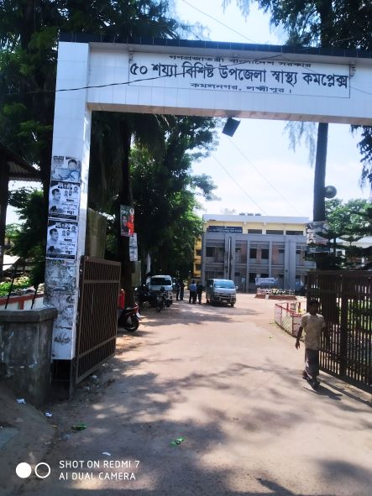

Fig-1: Front gate of Kamalnagar UHC

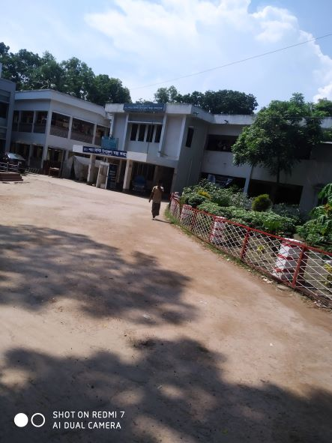
Fig-2: Clean and beautiful garden in front part of the UHC

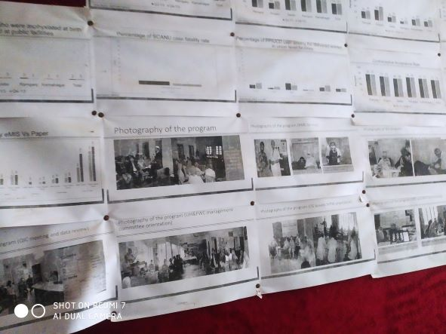
Fig-3: Display system is good but not updated

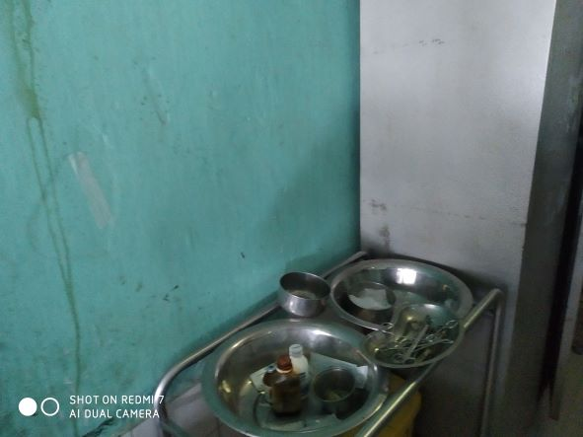
Fig-4: Instruments of emergency department

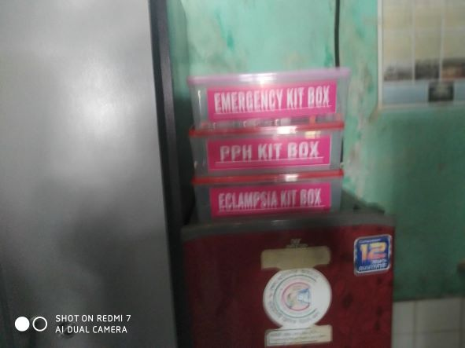
Fig-5: Emergency Kit boxes in emergency dept. (Good practice)

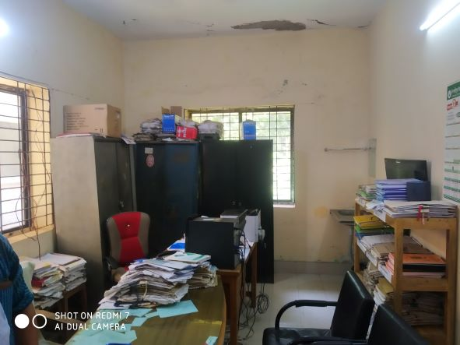
Fig-6: Office room of the UHC
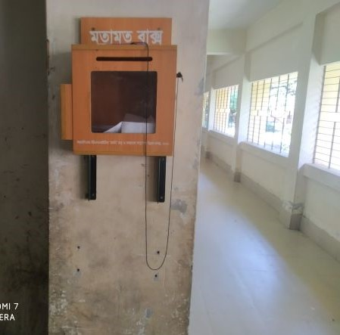
Fig-7: Suggestion box (Good practice)

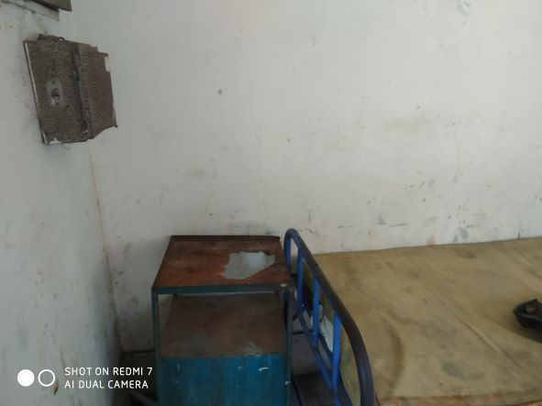
Fig-8: Unwanted items in the entry point of the indoor

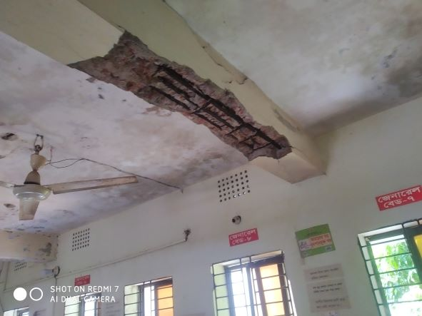
Fig-9: Risky condition of the ceiling of the indoor

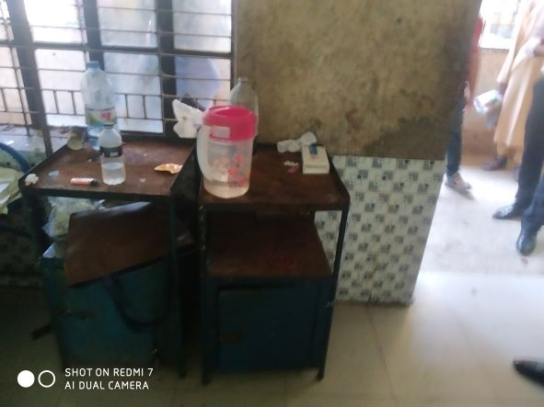
Fig-10: Unusable bedside locker in indoor

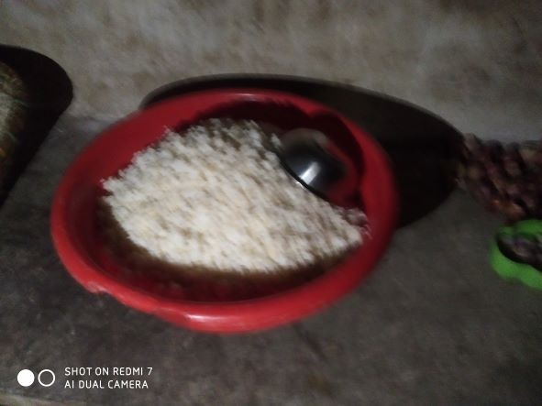
Fig-11: Supplied rice for the patients; needs to maintain hygienic condition

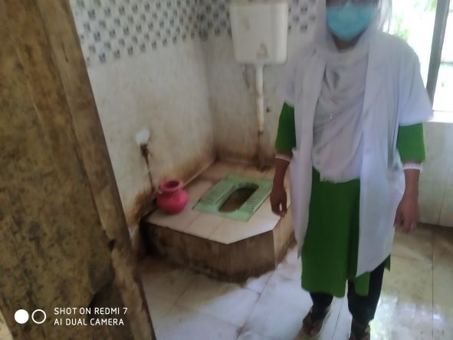
Fig-12: Unclean toilet in indoor

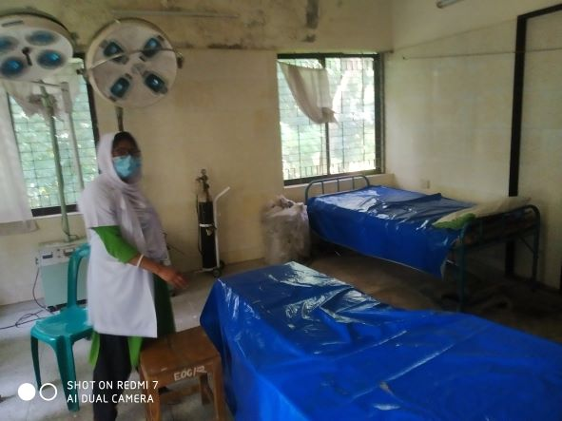
Fig-13: Patient’s bed in OT room

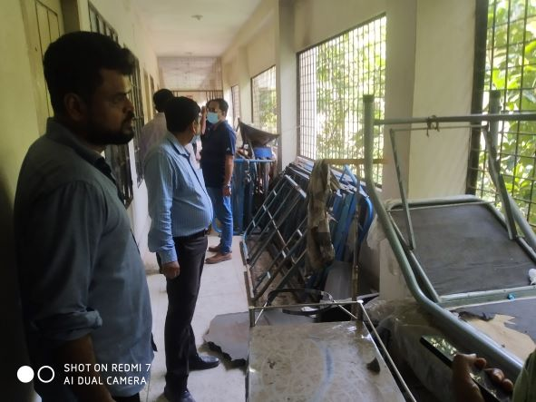
Fig-14: Unwanted items in hospital corridor

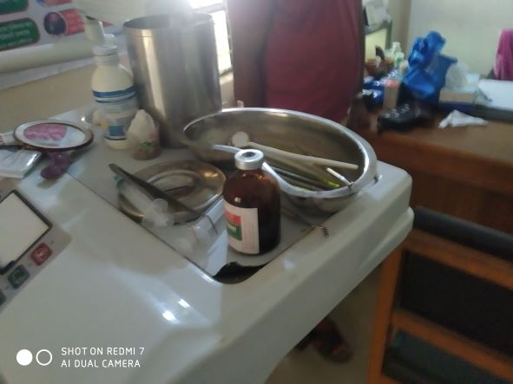
Fig-15: Uncleaned dental unit

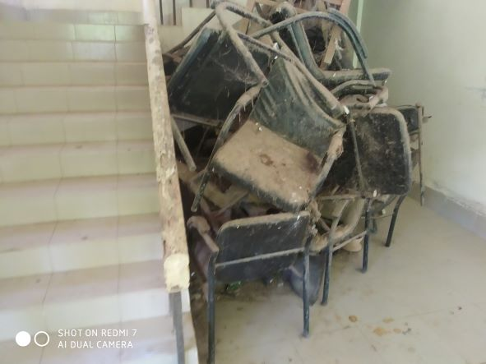
Fig-16: Unwanted items need condemnation

Health Profile of Kamalnagar UHC, Ramgoti, Laxmipur
Total population: 2,63,545
Union: 9 Sub-centre: 2 FWC: 4 Community Clinic: 22
Human Resources: 31 Bedded Hospital:
Sl. | Designation | No. of Post | Present | Vacant
 | UH&FPO | 1 | 1 | 0
 | RMO | 1 | 1 | 0
 | Junior Consultant: Medicine, Surgery, Gynae, Anestheology & Rheumatology. | 6 | 1 Medicine  1 Anaesthesia  1 Pediatrician  1 Gynae in deputation Kamlapur Railway Hospital | 2
 | Medical Officer | 8 (3+5) | 7 | 1
 | Nurses | 21 | 15 | 6
 | Mid wives | 4 | 4 | 0
 | Medical Technologist (Lab) | 2 | 2 MT (TB) | 0
 | MT EPI | 1 | 1 | 0
 | Dental Technologist | 1 | 0 | 1
 | MT (Radiology) | 1 | 0 | 1
 | SACMO | 1 | 1 | 0
 | Health Inspector (HI) | 3 | 0 | 3
 | Assist. Health Inspector | 8 | 7 | 1
 | Health Assistant | 42 | 26 | 16
 | CHCP | 22 | 22 | 0
 | Head Assistant | 1 | 0 | 1
 | Accountant | 1 | 0 | 1
 | Statistician | 1 | 0 | 1
 | MLSS | 2 | 0 | 2
 | Aya | 2 | 0 | 2
 | Cleaner | 1 | 0 | 1
 | Cook | 1 | 0 | 1
 | FWA | 1 | 0 | 1
 | Outsourcing: Cleaner, Cook, Guard, Ward boy, Aya. | 16 | 14 | 2

Status of Building Blocks of C-J Model in the Ramgoti UHC:
Sl | Criteria of C-J Model | Best | Good | Weak
 | Cycle stand close to the main gate |  |  | +
 | Health Education |  |  | +
 | Cleanliness & beautification |  | +
 | Separation of patients in out door & indoor |  | +
 | Blood doner list with 24/7 B.T facility |  | +
 | Birth- death recording |  | +
 | Reception Desk |  |  | +
 | Developed Emergency Dept. |  | +
 | 5S –KAIZEN implementation |  |  | +
 | Community Participation |  |  | +
 | Hospital activities Display |  |  | +
 | Corner based service |  | +
 | Cash counter for receiving Govt money |  |  | +
 | Devolped maternal health/labour word |  |  | +
 | Devolped paediatric health |  |  | +
 | Position in HSS score |  |  | +
 | Power point Presentation &Video on UHC |  |  | +
 | Knowledge about 7th Five Year plan & SDG. |  |  | +
 | Zero-Tollarance on corruption |  | +

Recommendations:
1. Indoor & OT services in the new building yet not started. It needs to be started as soon as possible.
2. Radiographer is needed for operating X-ray machine. If radiographer is not employed, they can start it by following Ramgoti UHC by local inititives. USG machine should be added and ECG machine needs to be replaced.
3. The location of the emergency department should be close to the emergency medical officer’s room. Sterility should be maintained. Privacy of the patient should be maintained properly.
4. Ceiling of the indoor ward should be repaired immediately. Close attention should be given on cleanliness in indoor. Indoor toilet should be cleaned properly. Unwanted items should be removed.
5. Suggestion box should be replaced to Complain and suggestion box.
6. Replication of C-J model will help in development of the quality of care.
7. Drugs and medical equipments are kept disorganized in the OT complex of the new building which should be organized in the store.
8. Unwanted items shoul be condemned as soon as possible.

